Figure List
PartⅠ

Chapter4 Ground Improvement with Admixture or Inclusion (Figs)’19.2.10

Fig.4.7 Example of sand compaction pile method on loose sandy ground
(Takahashi, 2008)
Fig.4.8 Example of sand compaction pile method on soft clayey ground
(Takahashi, 2008)
Fig.4.9 Principle of SCP (Fudo Construction, 1971)
Fig.4.10 Plane arrangement of SCP (Fudo Construction, 1971)
Fig.4.11 Procedure of sand compaction pile
(Yasuda et al. 1996, Modified by authors).
Fig.4.12 Designing chart of SCP method for sandy ground
(Fudo Construction, 1971)
Fig.4.13 Principle of densification by SCP (Suematu, 1991)
Fig.4.14 Mechanism of bearing capacity on composite ground
(Suematu, 1991)
Fig.4.15 Shear strength of composite ground (Suematu, 1991)
Fig.4.16 Case history of SCP (Provision by JAFEC, 2016)

Rubble mound
Quay wall
Sand compaction pile
Loose sandy
ground

Fig.4.7 Example of sand compaction pile method on loose sandy ground
(Takahashi, 2008)

Soft clayey ground
Sand compaction piles
Road Embankment
Fig.4.8 Example of sand compaction pile method on soft clayey ground
(Takahashi, 2008)

a) Original ground
b) After improvement
$$e_{1}$$
Soil particles
Pore
Sand pile
$$e_{0}$$
Fig.4.9 Principle of SCP Ground Improvement in Sandy Ground
(Fudo Construction Co., Ltd. 1971)

X₂
X₁
x
x
x
x

c) Parallelogram (rectangular) pattern
- Equilateral triangular pattern
- Square pattern

Fig.4.10 Plane arrangement of SCP (Fudo Construction Co., Ltd. 1971)

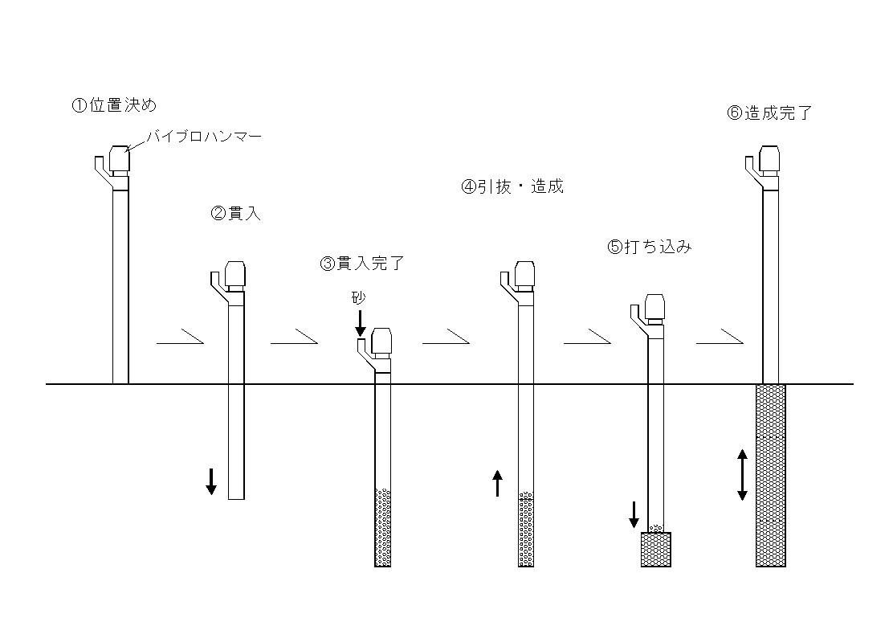
Step 3
Sand pile
Sand
Step 6
Step 5
Step 4
Step 2
Hopper
Casing
Vibrating hammer
Step 1
Step 1. Set the casing at the specified location.
Step 2. Actuate the vibrator for the casing to penetrate below the ground surface.
Step 3. Penetrate to the specified depth, then placed sand into casing through a hopper.
Step 4. Withdraw the casing top the specified level; the sand in the casing is discharged into the bored hole with compressed air.
Step 5. Insert the casing into the hole; the sand is compacted by vibration. Supply sand into casing.
Step 6. By repeating this procedure, the sand compaction pile is completed up to the ground surface.

Fig 4.11 Procedure of SCP method (Modified from Yasuda et al. 1996).

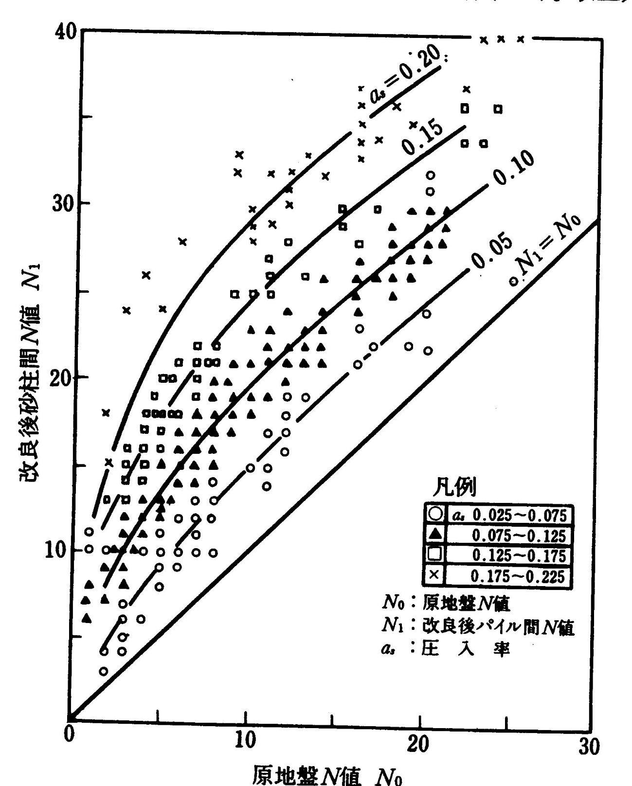
N-value after construction (N₁)
N-value of original ground (N₀ )
$N_{1}$=$N_{0}$
$a_{s}$=0.05
$a_{s}$=0.1
$a_{s}$=0.15
$a_{s}$=0.2
a_{s}: replacement rate
Fig. 4.12 Designing chart of SCP method for Sandy Ground
(Modified from Fudo Construction Co., Ltd., 1971)（Originalまたは最新版のものをいただきたいです）

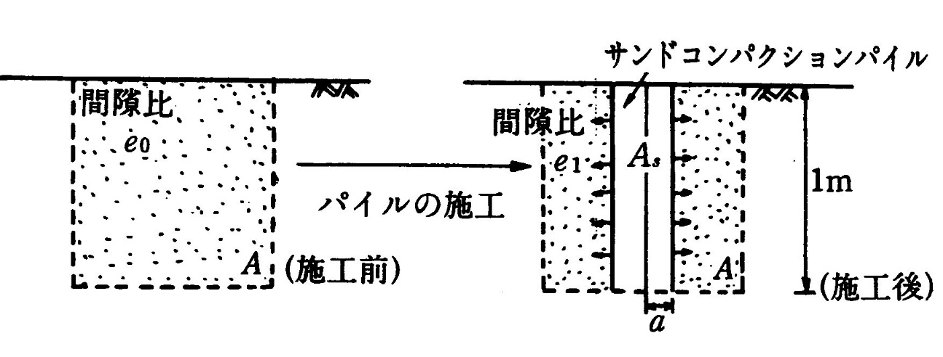
$$a$$
$$A_{s}$$
$$e_{1}$$
$$A$$
$$e_{0}$$
Sand compaction pile

Void ratio
A
$$1m$$
$$A$$
$$e_{1}$$
After
Improvement
Original state
Void ratio
- Change on void ratio after densification by SCP
d

$$A$$

d

- Symbols for Equation (4.2.4)

Fig.4.13 Principle of densification by SCP (Suematsu, 1991)
（最近のものがあればお願いします）

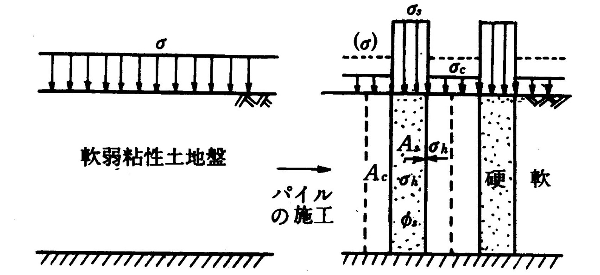
$$σ$$
$$σ_{c}$$
$$σ_{s}$$
$$A_{c}$$
$$σ_{h}$$
$$A_{s}$$
Soft clay
$$σ$$
Soft clayey ground

Hard
- Original ground (b) After improvement

Fig.4.14 Mechanism of bearing capacity on composite ground
(Suematsu, 1991)
（Originalをいただきたいです。最新版でも結構です）

$$α$$
o
R

$$σ_{Z}$$
Z

Z

$$τ_{c}$$
$$τ_{s}$$

Fig.4.15 Shear strength of composite ground (Suematsu, 1991)

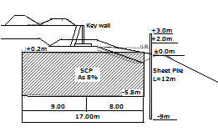
(a) Section
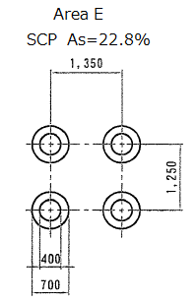

(b) Plane
Borehole3
Borehole1
Borehole2

(c) N-Value

Fig.4.16 Case history of SCP (Provision by JAFEC, 2016)
(これは日本基礎技術からいただいた事例ですが、もしこれより良いものがあればご提供ください)

